**National University of Computer & Emerging Sciences (NUCES) Islamabad,**

Department of Computer Science

**Programming Fundamentals – Fall 2022**

**LAB 11**



**Learning Outcomes**

In this lab you are expected to learn the following:

* Functions (definition, calling, forward declaration, default argument, overloading)

**Syntax and Basic Example of a Function:**

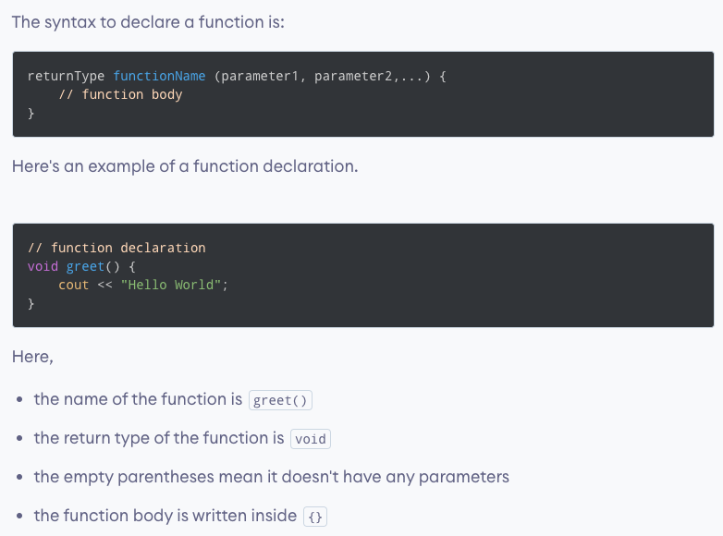

**How does the above program work?**

**Function example with parameters:**

**How does the above program work?**

**Function example with return type:**

**How does the above program work?**

**Function Prototype:**

**Function Example with Prototype:**

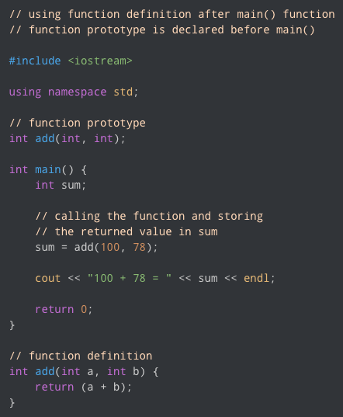

**Function Overloading**

**Function Overloading using different types of parameters:**

**How does the above program work?**

**Function Overloading using different number of parameters:**

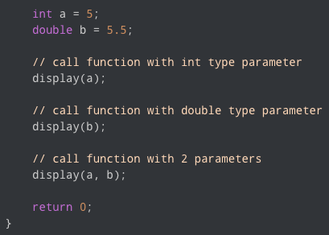

**How does the above program work?**

**Default Arguments**

**Working of default arguments:**

**Example of default argument:**

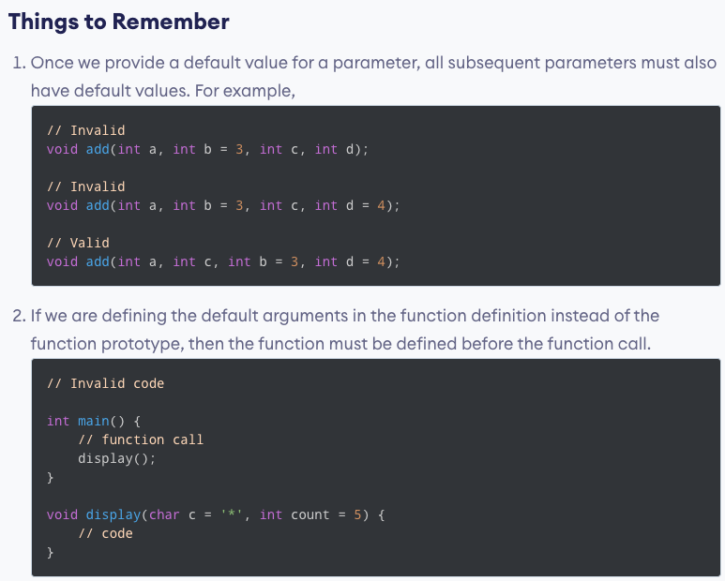

**Task 1:**

Define a function **hypotenuse** that calculates the length of the hypotenuse ‘c’ of a right triangle when the other two sides ‘a’ and ‘b’ are given. Use this function in a program using the loop to determine the length of the hypotenuse ‘c’ for each of the following triangles. The function should take two sides as arguments of type **double** and return the hypotenuse as a **double.** The prototype of the function is: **double hypotenuse ( double, double );**

The formula for hypotenuse calculation is as follows:

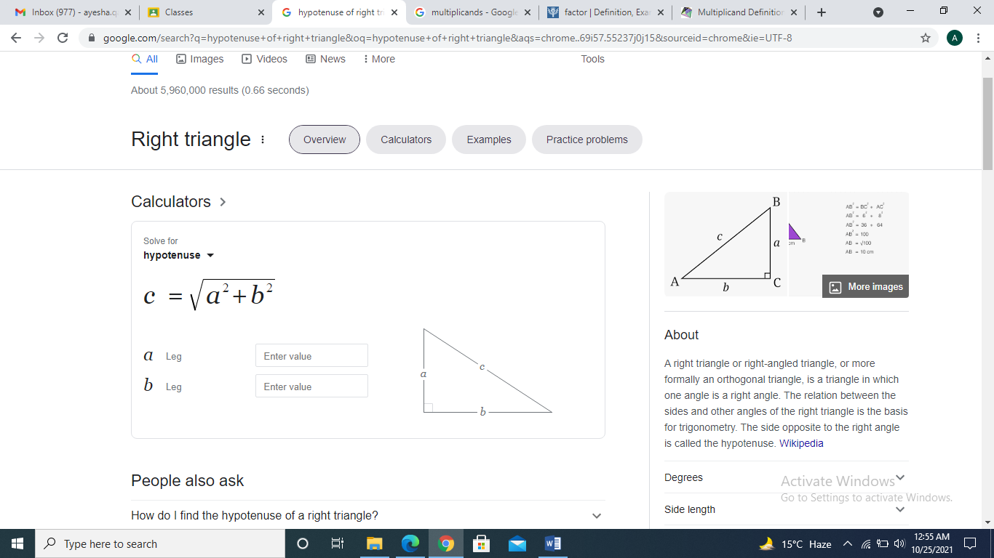

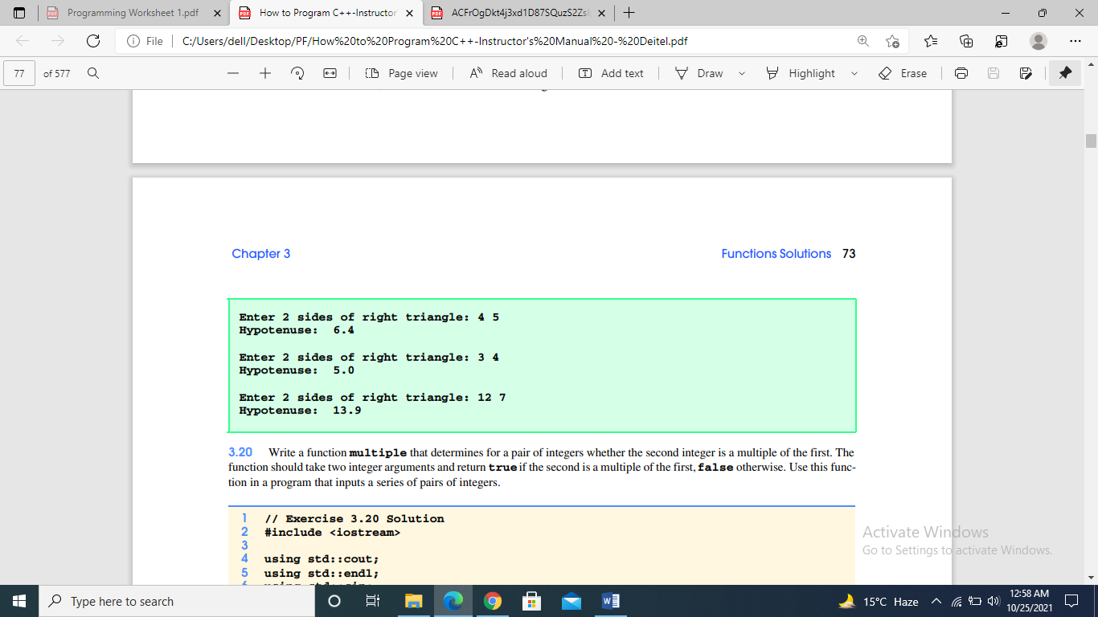

**Task 2:**

Write a function **multiple** that determines for a pair of integers whether the second integer is a multiple of the first. The function should take two integer arguments and return **true** if the second is a multiple of the first, **false** otherwise. Use this function in a program that inputs a series of pairs of integers. The prototype of the function is: **bool multiple ( int, int );**

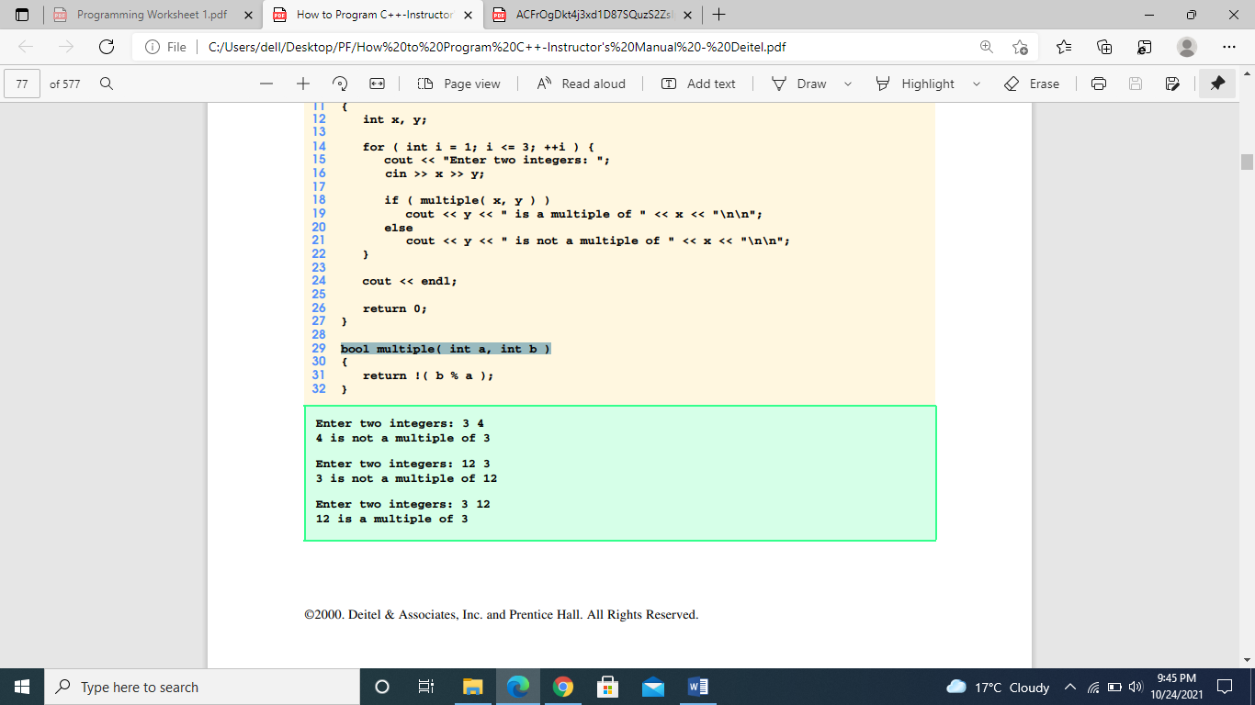

**Task 3:**

An integer number is said to be a perfect number if the sum of its factors, including 1 (but not

the number itself), is equal to the number. For example, 6 is a perfect number, because 6 = 1 + 2

+ 3. Write a function **perfect( )** that determines whether parameter number is a perfect number.

Use this function in a program that determines and prints all the perfect numbers between 1 and

1000. The prototype of the function is: **bool perfect ( int );**

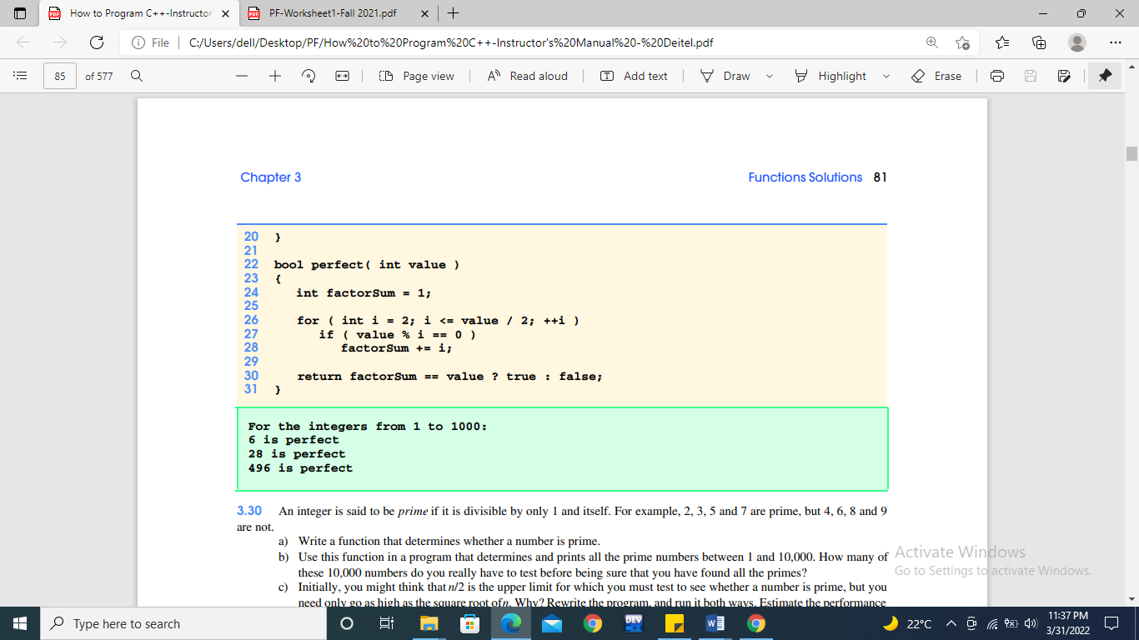

**Task 4:**

Given the dimensions of the 3D Shapes like **Cube**, **Cuboid**, or **Cylinder**, the task is to find the volume of all the 3D Shapes using Function Overloading.

**Help:** The given problem can be solved by creating the different functions having the same name, say **Volume** but different function definitions. For each shape and then overload all the functions by passing different parameters to them and then call all the functions from the main function one after another.

**Input:**

Cube: L = 2,

Cuboid: L = 3, B = 2, H = 3,

Cylinder: R = 1, H = 7  
**Output:**  
Volume of Cube: 8  
Volume of Cuboid: 18  
Volume of Cylinder: 22